ZHOU Kevin
Student ID : A0197122H
NUS - IE5101 - Applied Forecasting Methods
Professor : Chen Nan
Project 2 : Forecasting Highway Car Volumes


Table of Contents
2.1 Regression on Time 2
2.2 Exponential Smoothing 2
2.3 Free form forecasting 2

2.1 Regression on Time

2.1.1 Regression on time

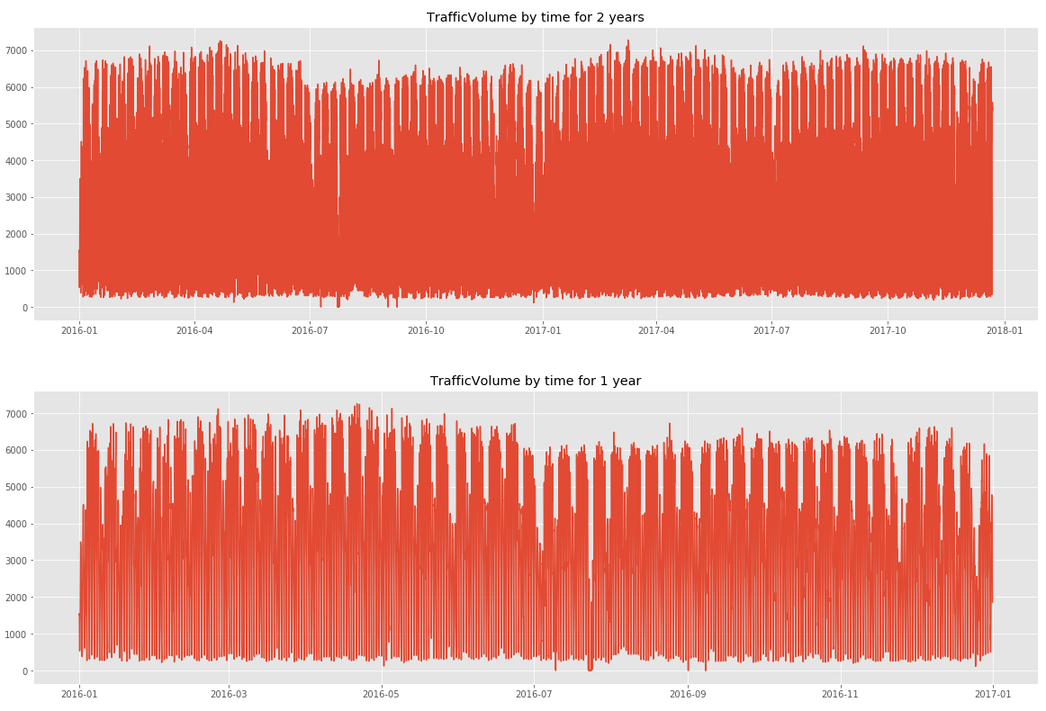
In this first part our regression will only consider the variables Time and TrafficVolume for prediction.

By plotting the Traffic volume, we notice some seasonality linked to the hour (peak around 7 am to 5 pm), to the day of the week (low traffic during the weekend) and and also to the month (plateau around April and minimum around July)
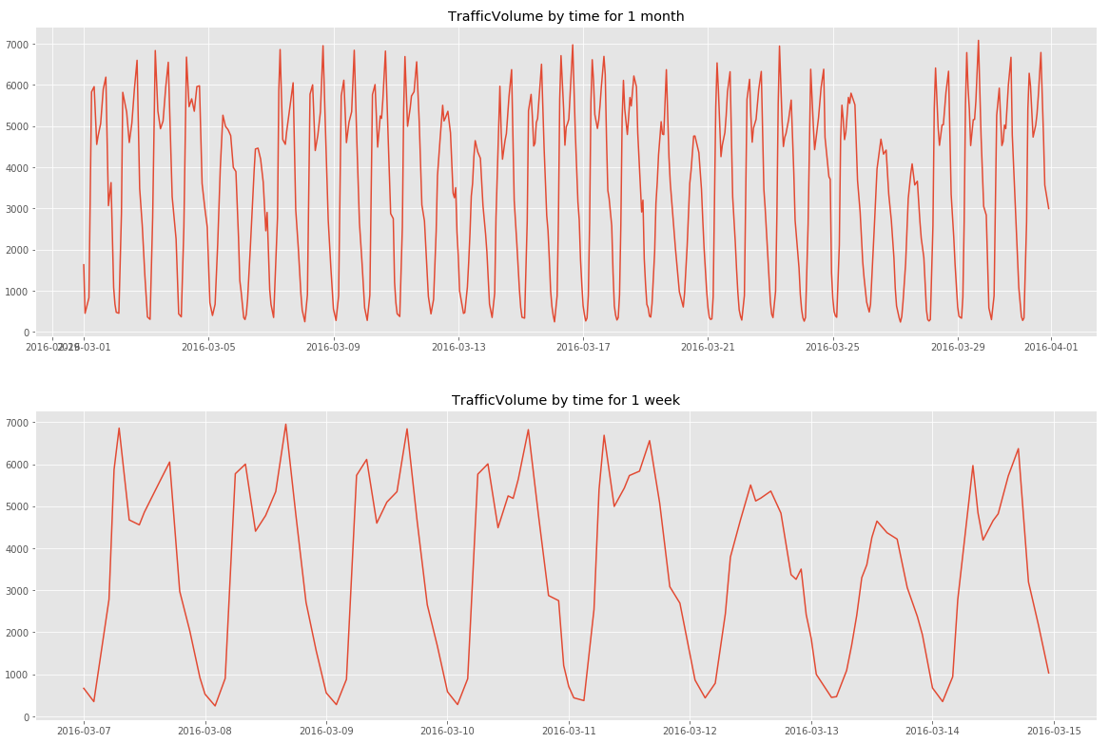
Hence to compute the linear regression, we will introduce dummy variables for the hour of the day, the day of the week and the month of the year and add the year to account for possible trend in time

This has yielded satisfactory results (below). All variables are taken are extremely relevant (p-values close to 0) except C(monthofyear)[T.12].
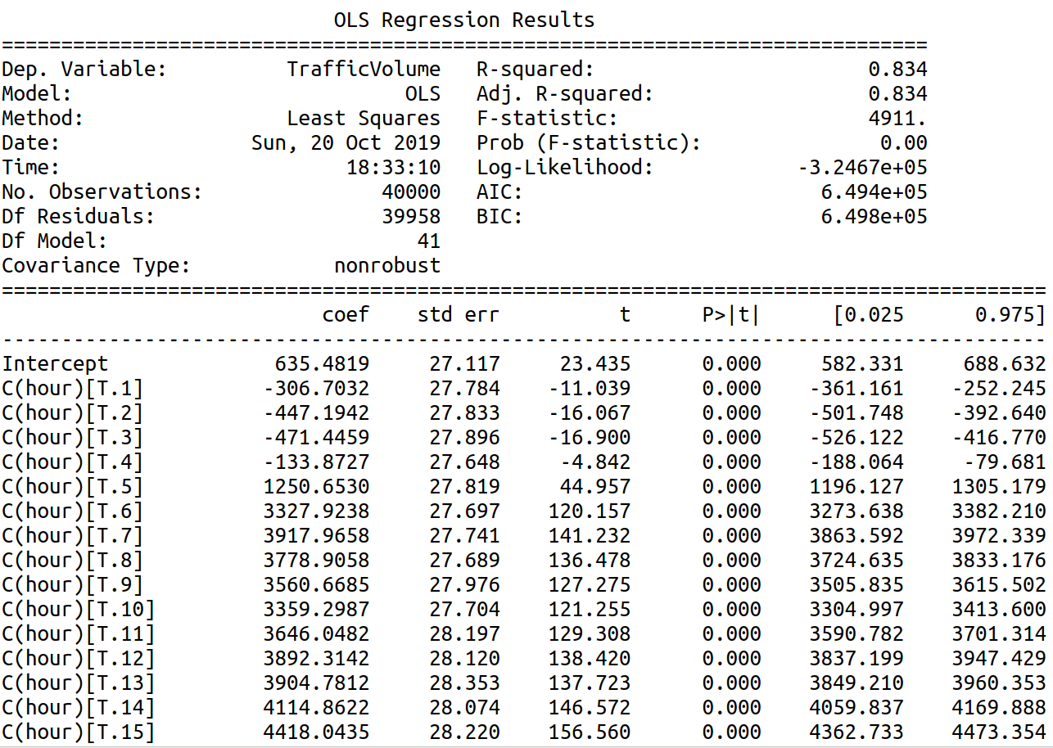
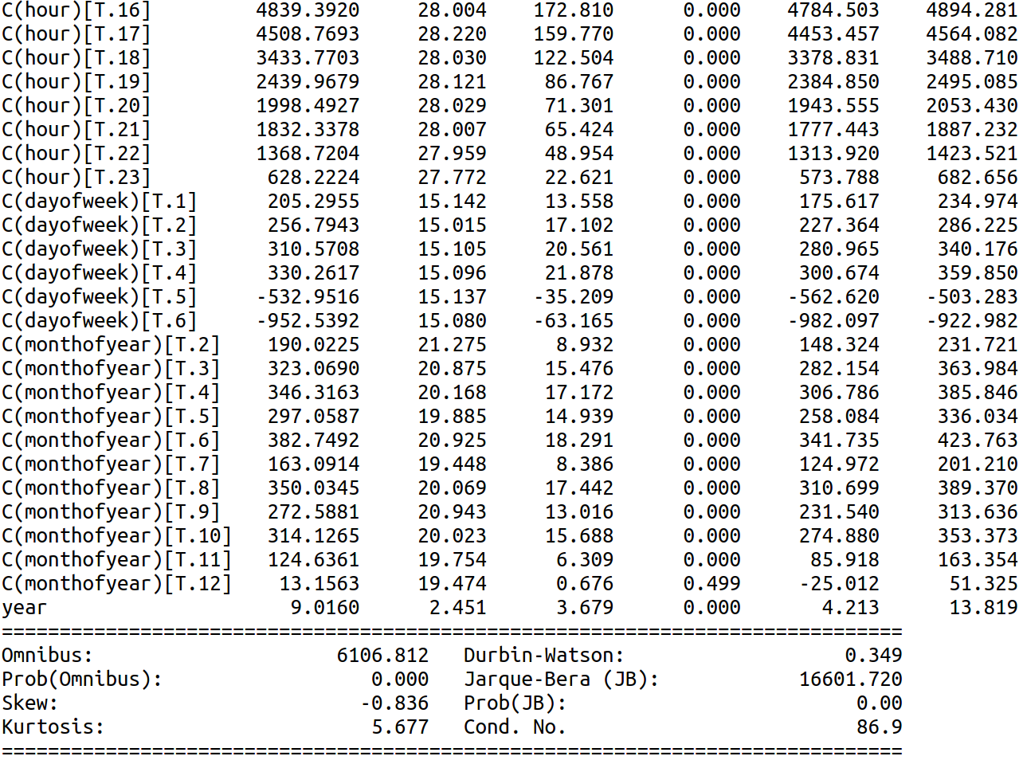

A full model regression with the list of possible features below have resulted in a slightly better R²-adjusted and smaller AIC. A stepwise forward selection regression to automatically select the best variables yielded similar results : better R²-adjusted and smaller AIC.
(‘hour', 'C(hour)', 'dayofweek', 'C(dayofweek)', 'dayofmonth', 'C(dayofmonth)', 'dayofyear', 'C(dayofyear)','C(weekofyear)', 'weekofyear', 'C(monthofyear)', 'monthofyear','year')

Both yielded slightly better results (1.1 point higher in R²-adjusted and 2000 lower in AIC) but have much complex models. For ease of interpretation, we will opt for the first regression model based on the AIC criteria.

Predicting future dates gives the right seasonal trend with however some values below 0.
Maybe some data cleaning necessary ?
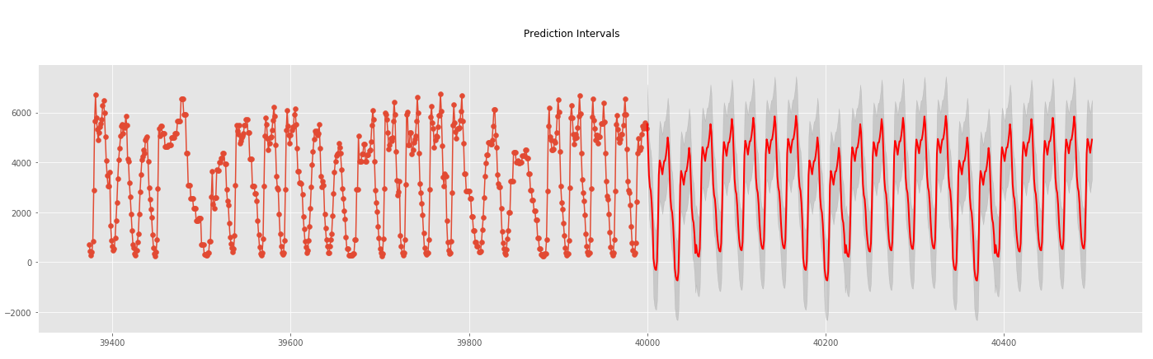
Diagnostic check
Residuals plot shows a non-normally distributed set of residuals
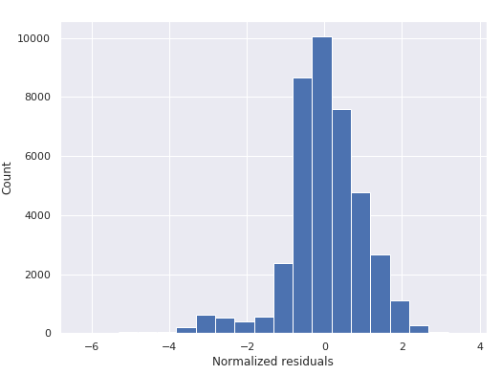
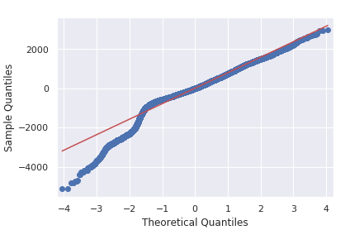
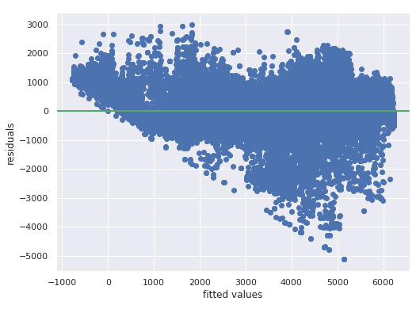

Model interpretation
To ease the interpretation, we have standardized the year variable : Year= Year -2012

2.2 Exponential Smoothing
In this task, you can apply appropriate exponential smoothing to make forecasting. Please explore
and verify your choice of model, and elaborate potential pros and cons of the model.

2.3 Free form forecasting

